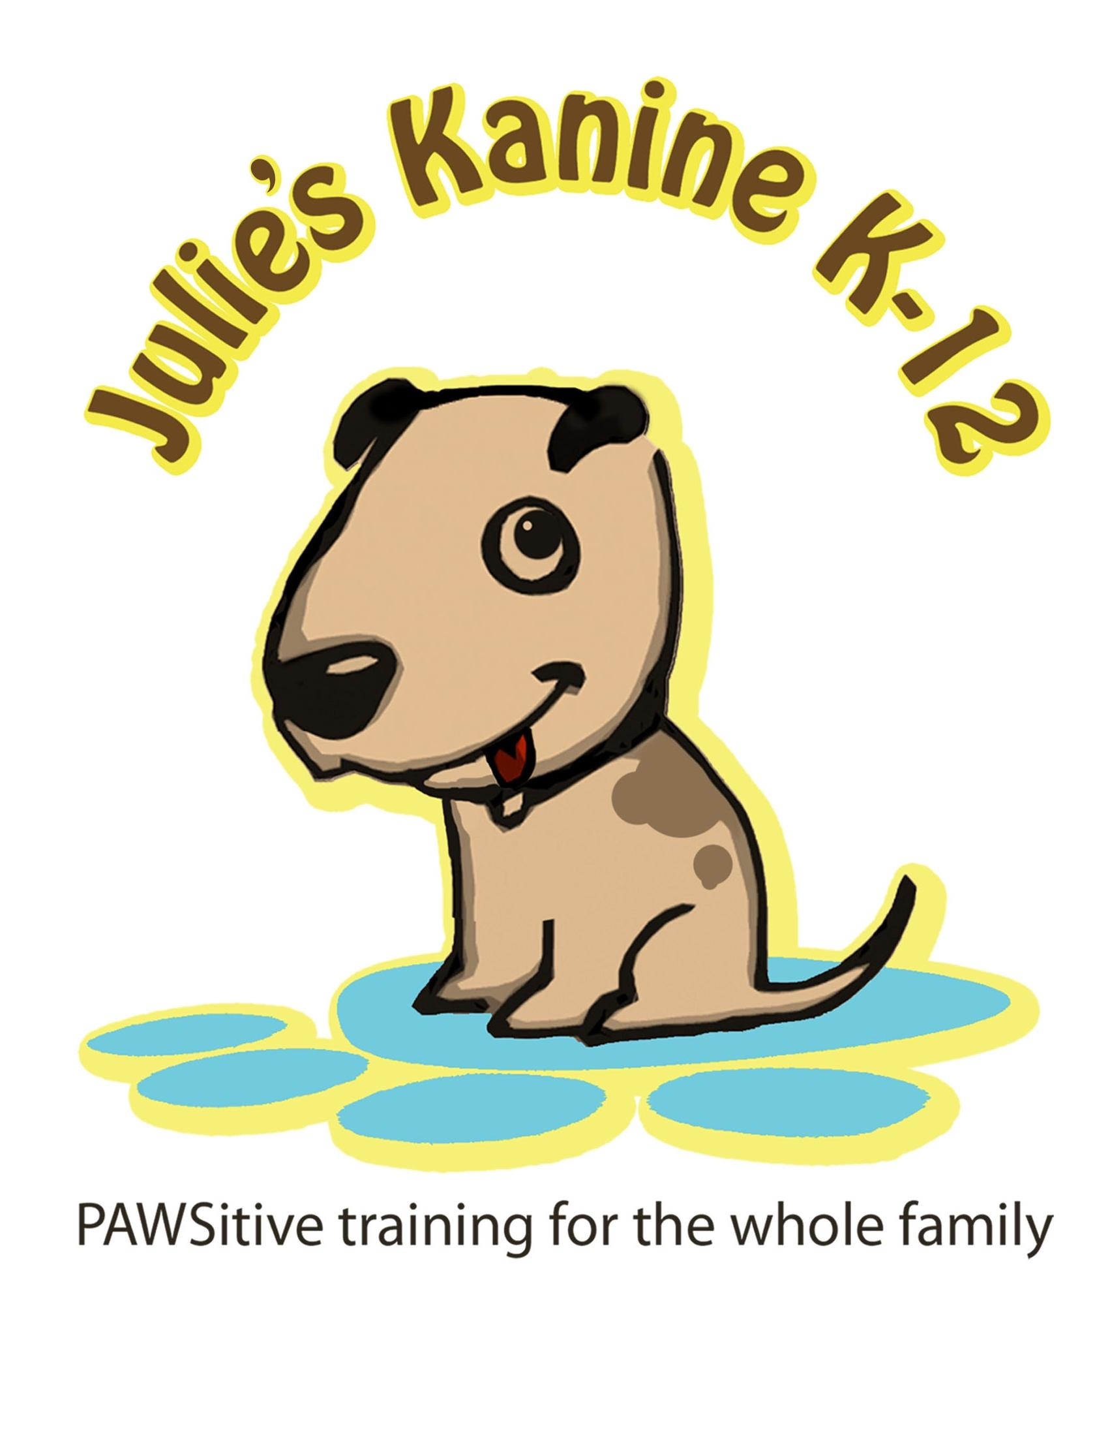

Julie’s Kanine K-12

(320) 249-3928

Brain Games

Hide and seek

Someone goes out of sight of the dog, like behind an open door. Then says the dog’s name, and the command “come”. The person can repeat the dog’s name as many times as they want, but the command only once. The dog will start to search for the person. When the dog finds that person, the dog is rewarded with lots of praise and a treat. Be creative and choose different hiding spots.

This will strengthen the come command and strengthen the bond you have with your pet.

Ping Pong Puppy

All members of the family can play this game. You need at least 2 people to play. Each person has a supply of treats. Have the people spread out in the room. The first person says the dog’s name, and the command Come. As soon as the dog looks at that person and moves one foot in that direction, the person starts praising the dog in a happy voice. When the dog reaches that person, they are rewarded with praise and a treat. While the dog is chewing the treat, the second person says the dog’s name, and the command comes. As soon as the dog turns toward person number two, and takes one step, person two starts to praise in a happy voice. When the dog reaches them, he is rewarded with praise and a treat.

Continue ping ponging the puppy between each person. This game strengthens the come command for the dog, in a fun way. Your dog will want to come to you, because you have made it a fun and rewarding thing to do.

Under the cup

Start with two Dixie cups or small plastic cups, and some great smelling treats. Let your pup see you place a treat under one cup. Then rotate the cups once, ending about shoulder width apart. Now tell your pup to “find it”. Be sure to use a happy, playful voice. The first couple of times, he may need a helping hand from you to get the idea. You want your pup to find the treat by using his nose. Once they decide which cup the treat is under, you want them to knock over, or move the cup to get the treat. Dogs generally learn this game rather quickly, and you will need to add more cups, and more rotations to add more of a challenge.

This is a fun game for your pup, using what he was naturally given, a great nose. It will also help strengthen the bond you share with your pup.

Laundry Basket

Use a standard laundry basket with holes, and your dog’s favorite toy or treat. Allow your dog to see you place the toy or treat on the floor, then place the laundry basket upside down over the toy or treat. Encourage your pup to “get it”, using a happy and excited voice. At first, your pup will look to you to retrieve the toy / treat. Do not get it for him. Continue to encourage him to “get it”. You may need to “show” him that he can manipulate the basket by lifting one edge up a bit, or by moving the basket a bit with your hand while continuing to encourage him.

If your pup doesn’t figure it with your encouragement after a couple of minutes, lift the edge of the basket so he can reach under and grab the toy / treat. Praise your pup and give lots of love. Try it again. He will come to understand it very soon and will become one of his favorite games to play.

This game helps your pup to use his eyes, his nose and most importantly, his brain to figure out how to get to that toy / treat.

Cupcake Tin

This is a very simple game, but one that does require a bit of brain work. Let your pup watch you do this. In a cupcake tin, place a treat in 4 of the 12 spots, leaving spaces between them. On top of the treats, and in the empty spots, place a ball. You can use a wiffle ball to start, so she can get a good whiff of the treats, or you can use tennis balls.

Encourage your pup to “get it”, or “find it”. She will need to move the ball to get to the treat. If she doesn’t understand right away, that’s okay. Lift a ball to show her the treat, then place the ball back on top of the treat. Encourage her in the happy voice to “get it” or “find it”.

Pick a Hand

Place a good smelling treat in one hand. Close both hands into loose fists, Hold them shoulder width apart, about nose high in front of your pup. Shhh, don’t say a word. Let your pup touch one of your hands, then open it up for them. If they touch the incorrect hand, they don’t get anything. But, if they have touched the correct hand, they get the treat.

This game requires them to use that wonderfully talented nose.

Treat Hunt

Hide a few treats around the house. Your pooch will again use that wonderfully talented nose to seek them out. In the beginning, you may need to put them in “plain sight”, just to give them the idea that following the nose is rewarded. Start with on the entry rug, next to the couch, in the middle of the hallway. As your pooch gets better and better, you will have to be a bit craftier in where you hide the treats. Perhaps under an inverted box, or under the corner of the kitchen rug.

If you do not kennel your pooch while you are gone, this is one way to stimulate your dog, and not associate you leaving as a bad thing.

Crawl

Have a treat in your hand, have your dog in the lay down position. Hold the treat just out of reach of your dog’s nose. She will stretch her neck out to get the treat, continue to hold it just out of reach. Just wait, eventually she will move at least one paw slightly forward. When she does, praise her and give her the treat. Place another treat in your hand, have her in the lay down position, and keep the treat just out of reach. She will move her paw forward a bit faster this time but wait until she moves both paws forward at least once. Then praise and reward her. Do this a few times, each time waiting until she moves the paws forward a bit further than the last time. Now add the command “crawl” when you have the treat out of her reach, before she starts to move her paws. Soon you will be able to tell her to “crawl”, and she will crawl to you. Remember to always praise first, then give her the treat.

Paws Up

Hold a treat slightly above a sturdy box or a low chair seat. Pat the box with your other hand to coax your pup to put her paws on the box top. As soon as both paws are on top of the box, praise her and give her a treat. When she does this twice, then add the command “paws up” while holding the treat over the center of the box top. When she responds positively to the command by putting her paws up for 4-5 times while you are holding the treat, try it without the treat as a lure. If she still puts her paws up when you give her the command, praise her highly and give her a treat.

This little game will help to build trust. You are asking her to do something she is not sure about, removing her feet from the floor. (Please make sure the box is sturdy, try a wooden box.) This is also the first step in teaching her to “bow her head”.

Bow

Using the same sturdy box you used when teaching your pup “paws up”, kneel in front of the box, with your pup to your side. Hold a treat in the hand closest to your pup. Use your other hand ,if needed to lure your pup to put her paws up or give the command “paws up”. As soon as she has her paws up on the box, use your hand with the treat to reach up under your pup, between her front legs, towards her nose. Slowly draw your hand back down towards her chest. When she bends her neck down, even slightly to get the treat, praise and reward her. If she stays on the box, again reach up between her front legs with a treat and lure her head down toward her chest. If she has stepped off of the box, give her the command “paws up” to get her back up on the box. This time, as soon as she starts to bend her neck, say the command” bow”. Remember to praise and reward her when she has 2 paws on the box, and her head is bent, even slightly, towards her chest. As she gets better, and bends her neck a bit further, you can require she hold that position for a few seconds before rewarding her.

This is not a game that will come quickly. This one will take time and practice. Be patient, never end this game while you or your dog are frustrated. If after a few attempts, your pup is not getting the hang of it, go back to something she knows very well. It could be a simple sit or crawl. Praise her when she does it correctly, give her the treat, and end the game training for the day. You always want to end any training session, either obedience or games training on a positive note for your dog. This will help ensure your dog will be a willing partner when it comes to training.

Shake

Hold a treat in your loosely closed fist, low to the ground. Now wait. The moment your dog lifts a paw, even slightly off the floor, use your other hand to gently grab the paw he has lifted. Praise and give him the treat. Do it again. The response of lifting his foot should be a bit quicker this time, so be ready. Again, gently grab the foot, praise and treat him. Now, you are going to add the command “shake” when you hold out your hand with the treat in it. As he lifts his paw, praise and reward him as you gently grab his paw. As you practice this, start to require he lifts his paw higher and higher before you grab it and reward him.

If he chooses to use his nose instead of his paw when training this, just ignore it. Don’t give any corrections, just wait for the paw. You will get it.

Figure 8

Hold several treats in both hands. Stand with your legs spread apart, and your pup on your heel up side. (For this explanation, I will have the pup on my left side. Adjust the motions if you heel up on the right.) Get your puppy's attention with the treat in your left hand.

With the treat held at nose height, say the command “cross”, as you move your left hand in front of your body to the space between your legs. When you get to the that space, use your right hand from behind you to reach between your legs and lure your pup go between them, then around your right side, (this is a great place to offer one of those treats she knows is in your hand.), then back to the front of you again, and towards the open space between your legs. Then use your left hand, from behind you, to lure your pup between your legs and back to the left side of you where she started. Praise her highly and reward her greatly.

When she has the hang of “cross”, try using body language to up the ante a bit. Try just a finger point (without the treats) when you say the command “cross”. Slightly bend your right knee and shift your weight to the right if that is the leg you want her to circle or bend the left knee and shift your weight to the left leg if that is the leg you want her to circle. When you up ante on what you want her to do, remember to up the value of the reward you are giving her.

Wipe your paws

For this, it is best to use a hard treat, the soft treats tend to squish, and this will make a mess!

Let your pup see you place a treat under the corner of the doormat. Encourage your pup to go after the treat by saying the command “wipe” in a happy / excited voice and tapping the doormat. If your pup loses interest, quickly lift the corner of the mat and let him have the treat. If he tries to use his nose to get the treat, hold the doormat down. Within a minute or so, he will probably scratch the doormat to try to get the treat – be ready! The instant he scratches, even once, praise and lift the corner of the mat so he can have the treat.

As he gets faster with his scratch when you say “wipe”, wait until he scratches twice, then three time and so on before he is rewarded. When he does the “wipe” on cue, with at least 3-5 scratches, stop putting the treats under the mat, and toss it on top of the mat for him, after he wipes his feet.

While this is a fun trick, it also helps to cut down on muddy or wet footprints in the house. It is a win- win for everyone!

Ice bucket - Summer cool down

You can use any size bucket or plastic bowl. Put fresh water in the bucket, add toys and treats, and place in the freezer overnight. Remove the frozen wonder from the bucket and give it to your dog….outside. I have found that if you layer the items it works best. Place a few inches of water in the bucket, add a tennis ball and a couple of fresh carrot pieces, then freeze it. (these will generally be visible and sniff-able when you remove it from the bucket). When that layer is solid, add another few inches of water, and more treats or toys, and freeze it. Continue this until your bucket is as full as you want it. On the top layer, be sure to leave something enticing sticking out the top to help get your pup interested. As a special treat, you can mix a small amount of chicken or beef broth to the water before you freeze to kick up the flavor. Try flavoring just one or two layers.

You will be amazed at how much your dog will enjoy this special hot weather treat. He thinks it's just fun, but you will also know that he is getting much needed hydration on a hot day.

Home spun fun

There are companies that manufacture agility obstacles, and treat games. They are very happy to sell them to you. But you can easily make them at home, for far less money. And let’s face it, your dog does not care if the obstacles he plays with does not have a fancy name on them, or if they cost $250.00, or $25.00. Your dog will be delighted to play with the wonderful things you have provided for him, that challenge both his body and his brain.

Totter board

You only need two things for this one. A plank about 6’-8’ long by 12’-16” wide, and a piece of 4” x 4” as long as your plank is wide.

Start by laying the plank flat on the ground. (don’t use the 4x4 yet, we will add that shortly). With a treat in your hand, lead your dog to walk the length of the plank. Repeat that several times until he is comfortable doing it. Remember to talk to him while he is doing it and reward him when he reaches the end. Now add the 4” x 4” under the plank, mid-way down the length. You have just made a small teeter totter for your dog. Now lure him to walk the length of the plank. When he reaches the middle, and teeter starts to totter, expect him to stop, and try to figure out what is different. Continue to talk to him and lure him down the plank. When his weight shifts, and the totter totters, he may well stop again, that’s okay, keep talking and luring him down the plank. When he gets to the end, you may see a bit of a startle response when the plank hits the floor, sometimes it makes a pretty loud noise. (You can buffer that noise by putting a rug or towel on the ground where the totter will hit on both ends.) When he completes one pass down the plank, be sure to praise him and give him his reward.

Some dogs find this the most delightful thing to do once they have figured it out. You may well catch them playing totter all by themselves. You can increase the height of the totter by using a different size post for the pivot point instead of a 4 x 4. If you want to up the ante on this one, paint the last 18” of the board a different color, and teach them to touch that colored area before getting off the plank.

Tunnel

Target has great hoops in the children’s toy section, and they are inexpensive.

The easiest way to teach your pup to go thru the tunnel is with 2 people, one on each end. Both people should have treats handy. First let your pup see you toss treats into the tunnel. The person on the opposite end from your pup calls them in a very happy voice. The dog will then have two things that will draw him into the tunnel, all the yummy treats, and one of his favorite people on the other end calling him. Once he goes thru the tunnel and gets to the other end, that person will praise and reward him, then toss a few more treats into the tunnel. The first person will then start calling him. As he goes back thru the tunnel, he will scarf up the treats along the way, hear you praising him, and then get another treat when he gets to the end of the tunnel. Your pup is rewarded at almost every step he takes when first learning how to run the tunnel. As he gets better at this, stop tossing the treats into the tunnel, only give them when he reaches the end.

You will be surprised how happy he will be when he sees you take the tunnel out of the closet for play time!

Hoop

This is also a great thing to find in a children’s toy department. It is a child’s hula hoop.

Start by having several treats in your hand, and the hoop resting on the floor. Reach, with a treat in your hand at nose level, thru the hoop from the opposite your pup is on. She will walk thru the hoop to get the treat. Great job! Step one complete. Have go thru the hoop a few times while it is on the floor. Now, raise it about an inch off the ground, and toss the treat to the opposite side she is on. She will notice the hoop is not on the floor, but will just step over it to reach the treat. With a few successes at this height, raise it again, and toss the treat to the opposite side. She may need to put a bit of a hop in her step now, depending on her size. Continue to raise the hoop up in small increments, rewarding and praising her at each level. Some dogs will stall when they notice they must jump to get thru the hoop the first couple of time, just wait, she can do it. You may need to lure them with the treat in your hand again instead of tossing it. Some wily dogs will go around or under the hoop the first few times they must jump.

Please keep in mind, you do not want to encourage dogs under 1 year to jump too high. Their bones are not done growing yet. As they get a bit older, you can ask them to jump higher.

Weave poles

You can purchase lengths of pvc pipe precut to 3” or 4” lengths, along with the connectors at most large box hardware chain stores. You will need enough for 4-5 uprights, (or more if you chose), and the “bar” will connect to that lays on the floor. Keep in mind, you will need an additional piece at each end to act as stabilizers. I I I I I

With several treats in your hand, held at nose level, lure your pup to weave between each pole as they go from one end to the other and back. Remember to praise the entire time as you lure them thru the poles. When you get to the end, give them a treat, then head back to the other end. You can use the command “weave” as they pass each pole. This is another game they will love to perform.

Flip the bottle

This one uses either pvc or wood to make at home. You will need 2 uprights, a dowel about 2 1/2’ long. And feet for stabilizing each of the uprights. You will also need 3 empty 1-liter bottles. Cut a small hole directly across from each other on the neck of the bottle, about 2 ½”- 3” from the top. This is for the dowel to thread thru.

Thread the dowel thru each bottle, make sure each bottle spins freely, now secure the dowel to the uprights. Let your dog watch you place some treats in each bottle.

You can teach her how to do this two ways. The first requires nothing of you, you can just sit back and watch her puzzle it out on her own, and she will. Or, you can show her the bottles spins, and that it will be rewarding when they do. Gently hit one of the bottles, so it spins and dispenses a treat. Then encourage her to hit the bottle with a paw, until a bottle spins and rewards her. When she is successful, remember to add the praise!

This is another great game to set up before you leave the house. Not only will this keep your pup engaged while you are gone, it will help teach her that it is not always a bad thing when you leave.